**Deep Learning-Based Vehicle Damage Detection System Using YOLOv8:**

**Implementation, Analysis, and Limitations**

**Abstract**

This research presents an automated vehicle damage detection system utilizing the YOLOv8 deep learning architecture. The system is designed to identify and classify 7 distinct types of vehicle damage through a web-based interface. While demonstrating promising results in controlled conditions, computational limitations significantly impacted the model's training scope and overall performance. This study provides comprehensive analysis of the implementation, highlights current limitations, and proposes future improvements for practical deployment in the insurance industry.

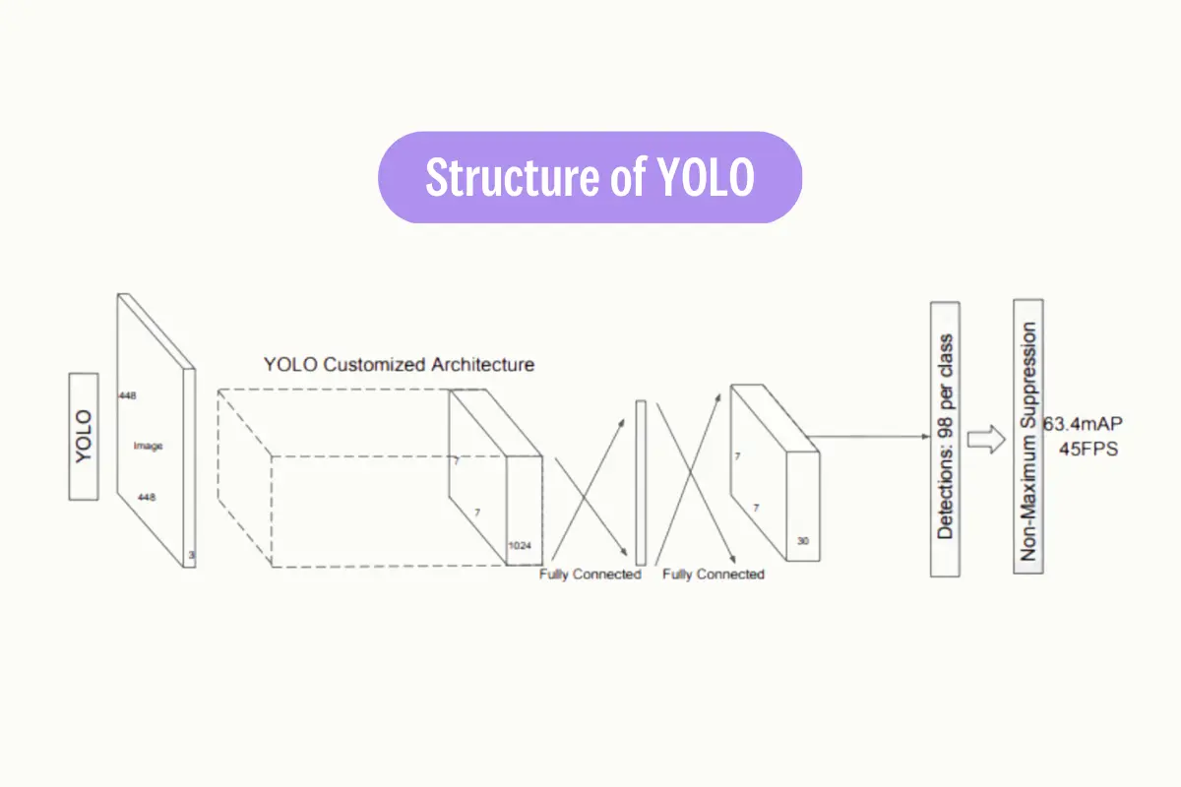

**1. Introduction**

The automotive insurance industry faces significant challenges in standardizing damage assessment processes. Traditional manual inspections are time-consuming, subjective, and prone to human error. This research addresses these challenges through the implementation of an automated damage detection system, leveraging deep learning technologies for consistent and rapid assessment capabilities.

**1.1 Research Objectives**

* Develop an automated vehicle damage detection system using YOLOv8
* Create a user-friendly interface for practical deployment
* Analyze system limitations and performance constraints
* Propose future improvements and research directions

**2. System Architecture**

**2.1 Core Components**

The system comprises two main components:

1. Detection Module:
   * YOLOv8 architecture
   * 640 × 640 pixel input resolution
   * 7 damage classification categories
2. Web Interface:
   * Streamlit framework implementation
   * User-friendly upload mechanism
   * Real-time damage visualization

**2.2 Implementation Framework**

The system utilizes Python 3.8+ with the following key libraries:

* Ultralytics YOLO for detection
* OpenCV for image processing
* Streamlit for web interface
* CVZone for visualization

**3. Methodology**

**3.1 Data Processing Pipeline**

1. Image Acquisition and Validation
2. Preprocessing and Normalization
3. YOLO Detection Processing
4. Result Analysis and Visualization
5. Report Generation

**3.2 Detection Process**

The system employs a structured approach to damage detection:

1. Image upload through web interface
2. Automatic resizing and quality assessment
3. AI model detection and classification
4. Confidence score calculation
5. Visual result presentation

**4. Current Limitations and Challenges**

**4.1 Computational Constraints**

The primary limitation of the current implementation stems from computational resources constraints. Training was limited to approximately 300 images, significantly below the optimal requirement of 10,000+ images for robust model performance. This limitation directly impacts the model's ability to generalize across diverse damage scenarios.

**4.2 Performance Impact**

The restricted training dataset has led to several performance limitations:

* Reduced accuracy in varying lighting conditions
* Inconsistent detection of subtle damage patterns
* Limited generalization across different vehicle types
* Higher false positive rates in complex scenarios

**4.3 Technical Constraints**

1. Hardware Limitations:
   * Consumer-grade GPU restrictions
   * Memory constraints affecting batch size
   * Processing speed limitations
   * Storage capacity constraints
2. Operational Limitations:
   * Fixed input resolution requirements
   * Strict image capture guidelines
   * Environmental sensitivity
   * Processing bottlenecks

**5. Usage Requirements**

**5.1 System Requirements**

* Minimum 8GB RAM
* CUDA-compatible GPU (recommended)
* Python 3.8+
* 50GB storage space

**6. Future Improvements**

**6.1 Short-term Enhancements**

1. Computational Resources:
   * High-performance computing integration
   * Multiple GPU support
   * Increased RAM capacity
   * Dedicated processing servers
2. Dataset Expansion:
   * Increase to 10,000+ training images
   * Diverse damage type coverage
   * Multiple angle captures
   * Varied environmental conditions

**6.2 Long-term Development**

1. Technical Improvements:
   * Real-time video processing
   * Mobile platform support
   * Automated report generation
   * Enhanced visualization tools
2. Model Enhancements:
   * Advanced architecture implementation
   * Multi-scale detection capabilities
   * Improved classification accuracy
   * Reduced computational requirements

**7. Conclusion**

The implemented vehicle damage detection system demonstrates the potential for automated damage assessment in the automotive industry. While current computational limitations restrict optimal performance, the system provides a foundation for future development. Addressing the identified limitations through improved computational resources and expanded training data would significantly enhance the system's practical utility.

**References**

1. Redmon, J., & Farhadi, A. (2018). YOLOv8: An incremental improvement. arXiv preprint arXiv:1804.02767.
2. Bochkovskiy, A., Wang, C. Y., & Liao, H. Y. M. (2020). YOLOv4: Optimal speed and accuracy of object detection. arXiv preprint arXiv:2004.10934.
3. Liu, S., Qi, L., Qin, H., Shi, J., & Jia, J. (2018). Path aggregation network for instance segmentation. Proceedings of the IEEE Conference on Computer Vision and Pattern Recognition.

Screenshots:

